Math In Our World
DLES Math Rules!!!

This booklet belongs to the

_____________________________Family

The ideas in this booklet are suggestions for you and your family. The purpose of this program is to provide families with math ideas outside of the school setting. We are encouraging you to use the ideas in this booklet, as well as your own. When your family uses math, be sure to spend time talking about the strategies you use to solve the problems.

Math In Our World is a school-wide Ducketts Lane Elementary School project. The goal is to help families think mathematically outside of the classroom. Your family will receive one booklet with math ideas that are suggestions for your family to use in different settings. When you go shopping, or to a restaurant bring the booklet with you. We are encouraging you to use the ideas in this booklet, as well as your own to solve math questions as you shop or dine out.
Each month all students will be given a week long homework assignment where they will be asked to choose one of the ideas from the suggestions in the booklet and use their Mathematical mind outside of the school setting. The assignment date, week to work on the project, and the due date are all indicated on the next page in this booklet. If you have more than one child that attends DLES, you may choose to complete the assignment as a family. If you choose to do one project as a family, please have the oldest child turn it in to their teacher with all family member names included.
Use the following suggestions and send a well-developed project to your child’s math teacher on the assigned due dates. The suggestions include, but are not limited to posters, stories, and illustrations. These ideas will be posted on our math DLES Web page. Chosen projects will be shared in the classrooms, in the community, and on our morning announcements.
How Much?

Choose several items to purchase. Ask your child to estimate how much the total cost of all of the items will be. You can go to Scholastic, or any other favorite store on-line.
- For primary stick to 2 or 3 items that will cost less than $1.00
- For intermediate students you can choose items that cost up to $10.00.
- For students that are up for a challenge, have them estimate the total cost of your purchase.

- Pick two or more items that you need to purchase.
- Use mental math to try to guess what the total will be.
- When you take the items to the register, compare your estimated cost to the actual cost.

Helpful Hints

- When you add costs, work on chunking amounts together to add up to a dollar. Look for compatible numbers. For example if something costs $6.45, and another item is $4.60, the .60 and the .45 can be added together to total 1 additional dollar. $6.00 + $4.00 + $1.00 will cost around $11.00.
- Keep a running total by rounding your items to the nearest dollar.

Be sure to limit the number of items so the children can be successful

Coupons

Cut out grocery store coupons.

- Tell how much money you can save on each coupon.
- What coin combination could you use to total that amount? For example, if you save 20 cents on detergent, say 2 dimes.
- How much total money can you save with all of your coupons? What if each coupon is doubled?
- What could be purchased using the money you saved from the coupons?
- How much money could be saved with 4, 5, or 6 coupons for the same item?
- How could that amount of money be counted out in coins and bills?
- What could be purchased with those savings?

Helpful Hints

- Be sure to use chunking and compatible numbers to add amounts in your head. This is when you put friendly numbers together first. For example, if you are adding something that saves .50 cents and another coupon that saves 1.25, add the .50 + .25 to get .75 first. Then add the dollar amounts.
- You can use many combinations of coins to total different amounts. You can get .50 with 5 dimes, or 2 quarters, or 2 dimes and 6 nickels. Be as creative as you want.
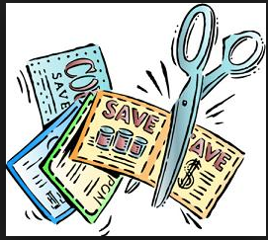

Suggested ideas for sharing with Ducketts Lane Elementary School and the Community:

- Create a power point that is no more than 5 slides to share your experience.
- Write a short paragraph to share with your classmates to explain how you used math outside of the classroom.
- Make a cartoon strip to illustrate your math activity.
- Write a story problem for other students to solve about your adventure.
- Write a letter to the store explaining how you used math there.
- Make a well-designed poster with pictures, numbers, and words.
- Write a short story about the problem you solved.
- Write a speech informing others how you solved a problem.
- Create an infomercial or skit about the problem.
- List the items you bought in order from least to greatest.
- Make a math game about your adventure. Bring it to school to play at recess.
- Use your own imagination and create your own idea for sharing great math activities with your classmates

Math Teacher Name: _________________________________
Justine Sillers
Team 5 ITL
Ducketts Lane Elementary School
justine_sillers@hcpss.org

Randi B. Blue
Math Support Teacher
Ducketts Lane Elementary School
randi_blue@hcpss.org

Assignment Date Information
Month | Assign Date | Week to work on | Due Date
October | 10/9/15 | Week of Oct. 12 | 10/19/15
November | 11/13/15 | Week of Nov. 16 | 11/23/15
December/January | 12/23/15 | Week of Jan. 4 | 1/11/16
February | 2/12/16 | Week of Feb. 15 | 2/22/16
March | 3/18/16 | Week of Mar. 21 | 4/4/16 or 4/5/16
April | No Homework due to PARCC
May | 5/27/16 | Week of May 30 | 6/6/16

Additional Resources

- Student Mathematics Activity Resource Tools or SMART Pages. http://smart.hcpss.wikispaces.net
- DLES Math Website

Get Into Shape Look at the following shapes.

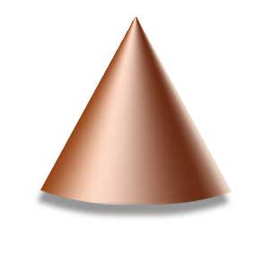
Cone Cube Cylinder Rectangular
Prism
Look at the pictures on this page.

Suggested Activities:
- Look for different shapes around the store.
- Try to find circles, squares, rectangles, ovals, and triangles.
- Challenge yourself by looking for more unusual shapes like trapezoids, rhombi, and parallelograms.
- As you walk around the store, look at the different packages.
- Locate 2 or 3 items in each isle and identify the type of package it is in.
- Which items in the store are solid?
- Which items are flat?
- Which items have rectangles for faces?
- Which items have squares for faces?
- Which shapes have circles as faces?
- What shapes stack easily. Why might this be important?
- What are the dimensions of the container?

Helpful Hints

- Dimensions are measurements; length times width times height
- Faces are the surfaces on the outside of the object. A cube has 6 faces.
What are the ingredients?

This card can be used when buying food.

Look at the Nutrition Facts, information about the products on the back or side of a box of cereal or other food item.
Read and interpret the information provided.

Possible questions:
- How many calories are there per serving?
- How many calories would there be if you ate two servings?
- If everyone in your family ate one serving, how many grams of carbohydrates would you have consumed?
- What does the chart tell you? Discuss it with the adult with you.
- Look at the grams of sugar in your item. Look for another box of a similar food item that has less sugar than the original.
- Look at the chart of percentages. List them in order from highest value to lowest value. You can do this orally with your child.

Helpful Hints

- Usually the Nutrition Fact information is on the side of the box. The serving size is always at the top. Nutritional information is usually listed last.
- The abbreviation for grams is g.
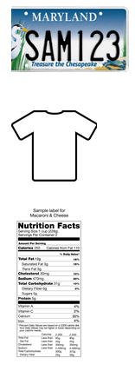

Below are samples of the label that you will place on your project.
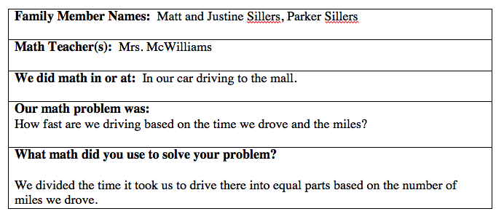

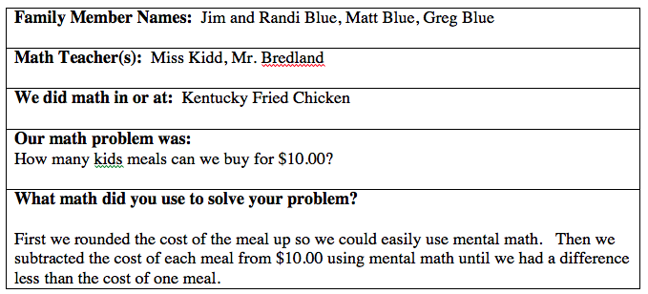

Percentage

At the Barber/Beauty: Look at prices for haircuts in the local paper, on-line, or call a local salon

- Identify the cost of a basic haircut. You want to tip the stylist 10% of the cost of the hair cut. How much tip should you give the stylist? What was your total cost including the tip?
- What would the cost be if you and your sibling both got a basic haircut? What you be the cost of the tip for you and your sibling.
- What is the least expensive service they offer, and how much does it cost?
- Write a problem that someone else in your family can solve.
- Write an explanation to explain how you would figure out 15% of the total cost of your haircut. How about 20%?

Helpful Hints

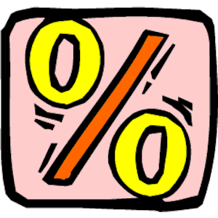
- Find the equivalent decimal for the percent (example 10%=10/100 10/100 is the same as 10 divided by 100 or .10). Multiply the decimal by the cost of the haircut. For example if a haircut is $18.00, you would multiply this by .10. See if your children can discover that you just move the decimal over to the left one space. Then see if they can explain why the tip is $1.80. Ask them: Can you use this to figure out 15% and 20%?

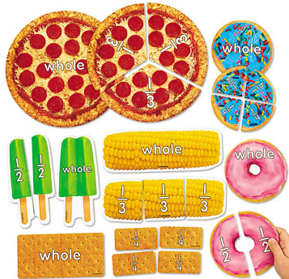
Money and Fractions

Suggested Activities:
Look at a grocery store receipt, a website, or at the local paper for grocery store ads.
Estimate the cost of food at the Deli counter.

- Identify the cost of one pound of deli meat (ham, turkey, and bologna). How much is one half pound of the same meat? How much is 1/4 pound of the same meat? What is the difference in cost between the one half pound and one quarter pound?
- How much is one pound of ham and one pound of American cheese?
- Which cost more; one pound of ham or one pound of cheese?

Helpful Hints

- Ask you children why you can take the cost of a pound and divide by two to get one half (1/2).
- How can you use ½ to calculate the cost of ¼?
Can you get one quarter (1/4) by divide one pound by four or one half pound by two.
- When phrasing your question choose words like and or or and discuss how it changes your answer.

Measurement

Suggested Activities:
Predict how much milk or juice is needed for the week.

- We are purchasing three gallons of beverages (milk, juice, or soda). Predict how many pints would be in three gallons, how many cups are in three gallons, or how many quarts are in three gallons.
- How much would three gallons of milk cost?
- Discuss how much money would be saved on various items using a coupon.

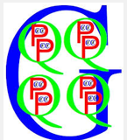
Helpful Hints

- 2 quarts = ½ gallon
- 4 quarts = 1 gallon
- 2 pints = 1 quart.
- 2 cups = 1 pint
- Look at metric measurements and compare sizes too.
- The students have learned the Giant G story. Ask them to share it with you. (There once was a giant (Gallon) kingdom. There were 4 Queens (Quarts). Each queen had 2 princes (pints) and each prince (or princess) wore 2 crowns (cups).

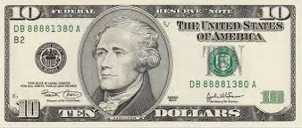
What can you buy?

Choose an amount of money.
It is suggested that you stay between .25 and $1.00 for primary. You can choose up to $10.00 for intermediate children.

- Ask your child to pick an item in a store ad that he or she could buy that costs less than the amount you chose.
- Ask your child to find 2 or more items that he or she could buy so that the total cost will be less than the amount you chose.
- Ask your child to figure out how much change they would receive if they bought the item(s) without tax.

Helpful Hints

- Stick with lower costing items for younger children.
- The dollar amount should be changed to fit the store and your child’s math level.
- Ask your child to share the strategy they used to calculate the change. Repeat what they explained to make sure you understand the math thinking. Then share your strategy. Discuss why each strategy is efficient.

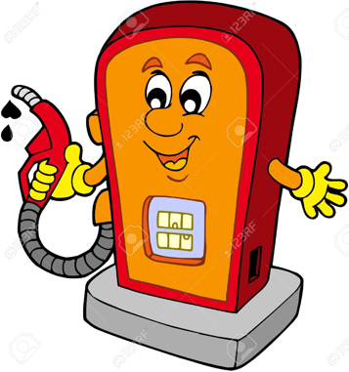
Gallon of Gas

This card can be used at a gasoline station.
- Look at the different prices in gasoline. Which one costs the most? Which one costs the least? What is the difference between the two prices?
- How much would 2 gallons of regular gasoline cost? How about 15 gallons?
- Suppose you had $10.00 in your wallet, how many gallons of gas could you buy?
- If you purchase gas, watch the numbers change as you pump. Do the numbers get smaller or larger? About how many gallons were pumped when you reached $10.00.
- Is the length of the pump hose longer or shorter than your car? How do you know?
- Using the window washer squeegee, how many strokes do you think it will take to cover the area of the front windshield? If possible, clean the windshield to count your strokes and see how close your estimate was. Do you think it would take an adult more or less strokes to find the area?

Helpful Hints

- Allow your child to explore the numbers around a gas station (signs, prices and machine).
- When finding the difference between two prices (#1), you may want to count up from the smaller amount to the larger amount. Remember to share the strategy and the answer.
- When working to find the price of 15 gallons of gas (#2), first think about how much 10 gallons would cost. Divide that in half, which will give you the cost of 5 gallons. Now you can find the cost of 15 gallons (10 + 5)!
License Plate Riddles

This card can be used in a gas station or anywhere cars can be seen.

Suggested Activities:

- Find the license plate on two cars, or have an adult create a license plate for you. What single number is the least? What single number is the greatest? What double digit is the largest? What double digit is the smallest?
- Looking at a license plate, how many numbers are odd? How many numbers are even?
- Find a license plate on a car and add all of the numbers together.
- Looking at a license plate, what is the largest 3-digit number you can make?
- Using the numbers on a license plate, can you make the number 5 using 2 numbers? (ex. 663M218, 3+2=5). Can you make 5 using 3 numbers? (3x2)+1
- Looking at the letters on two license plates, match each letter to its worth (A=1, B=2, M=13, Z=26). Which plate has the highest value?
- Can you find numbers that add up to your age?

Helpful Hints

- Try to find numbers that add up to 10.
- Look for doubles. 22, 44

Clothes

This card is good for using at all clothing stores or a department store advertisement or Internet ad.

Look for clothes you want to buy.

- Identify an item you could buy for $12.00.
- If you bought 4 items that cost $12.00, what would your total cost be?
- Look for an item that you could buy for under $20.00. How much change will you get back from your $20.00?
- If you have $50.00, how many pieces of one item can you buy?
- Find some items that are on sale. If the item is 20% off, how much money will you save?
- If the item is on sale for 33% off, how much will it cost?

Helpful Hints

- Estimate: round each item to the highest dollar when you deal with money. For example if something costs $3.25, think of it as $4.00 when you are trying to purchase more than one item. We do this so we are sure we have enough money to cover the total cost of our purchase.
- Practice your mental math. Figure out your change by counting up from the cost of the item(s) you are purchasing. For example if you have $5.00, and your total purchase is $3.65, add .10 to get to 3.75, then add .25 to get to $4.00, then add one more dollar to equal $5.00. Your change would be .10 + .25 + 1.00= $1.35.

How does this measure up?

Suggested activities:
- How many steps will it take you to get from the front door to the back of the store?
- Use a ruler to measure packages.
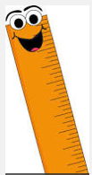
- Find something in the store that is approximately 10” long. Now find something in the store that is twice as long.
- Find something in the store that has measurement markings on it.
- Read the nutritional information on the packages of your favorite foods. Share what you notice about serving size, % of daily recommended allowances, and the units they use to measure different aspects of each product.
- Bake or cook one of your favorite recipes.
  - Double the ingredients
  - Half the ingredients
  - How much would you need of each ingredient to prepare enough to feed 35 people?

Helpful Hints

- When looking for measurement markings try the medicine aisle, or baking aisle.

Parts of a Whole

These activities are good at a restaurant.

- What is the cost of your meal?
- How many people do you think are in the restaurant?
- How many people can fit at 6 tables or booths? Will this answer always be the same? Why or why not?
- Read how much your favorite meal costs.
- If you had $25.00, how many of your favorite meals could you buy?
- If you ordered half an order, what would it cost you?
- Look at what everyone in your family ordered, estimate the total cost of the bill.
- You want to tip the waiter or waitress 20%. What will the tip be?
- What is the ratio of adults to children? Is it the same as the ratio of children to adults?
- Suppose you are a waiter that is responsible for 10 tables. Each table seats 4 people. How many of each ite would you need to set all 10 tables?

Helpful Hints

- Keep it fun. Try to do problems that the family can figure in their head. This is called mental math. We practice this in our math classes all the time.
- Share your secret for finding the tip. Sometimes people look at the tax, 6%. How can you use this to find 18%? (Multiply it by 3)
- How can you use what you know about finding 10% to figure out a 20% tip? Ask your children to share their thinking. How did they solve some of the problems?

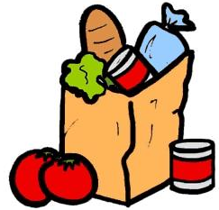
What’s in the Bag?

This card can be used anywhere.
Bring your bags home and do some work before unpacking them.
- When you get home guess how many items are in your bags.
- Is the bag full, half full, 1/4 full?
- How many more items could it hold?
- Estimate the weight of the bag. Weigh it. How close were you?
- Pick one item that you purchased. How many of that item could you fill the bag with? How did you calculate your answer?

Helpful Hints

- A benchmark is something you use to estimate when you measure. When you look at 5 items, look at how big they are all together, and then try to see how many times that total size will fit into the whole bag.

